DATE | 20-02-2026
TEAM ID | LTVIP2026TMIDS90622
PROJECT NAME | SMART SORTING : TRANSFER LEARNING FOR IDENTIFYING ROTTEN FRUITS AND VEGETABLES
MAXIMUM MARKS | 3 MARKS

6.3 DATA PREPROCESSING
Data Visualization:
The provided Python code imports necessary libraries and modules for image manipulation. It selects a random image file from a specified folder path. Then, it displays the randomly selected image using IPython's Image module. This code is useful for showcasing random images from a directory for various purposes like data exploration or testing image processing algorithms.
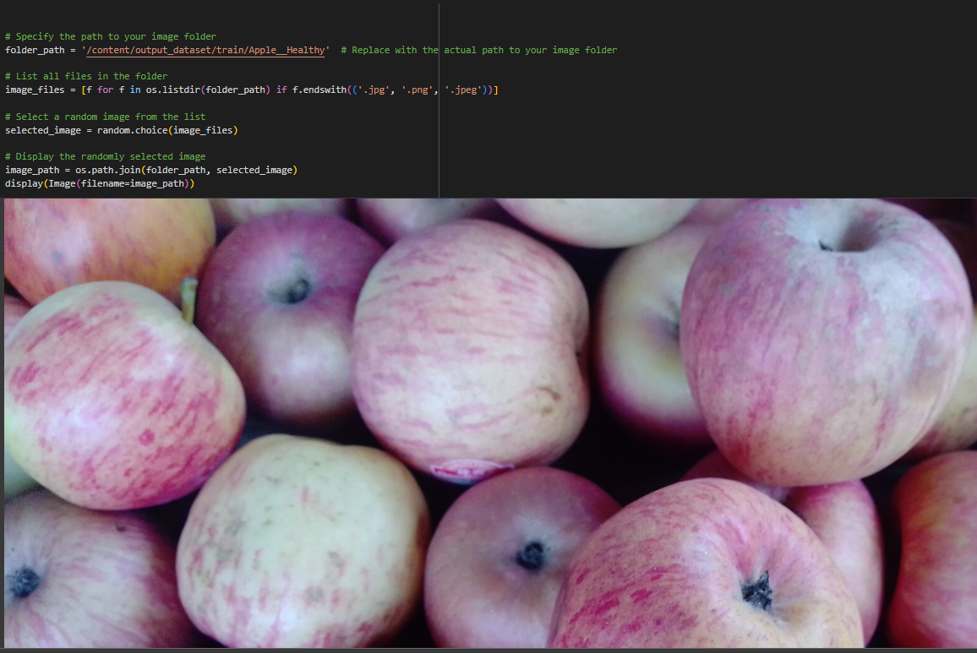
In the above code, I used class Apple_healthy 0 for prediction, This code randomly selects an image file from a specified folder (folder_path) containing JPEG, PNG, or JPEG files, and then displays the selected image using IPython's display function. It utilizes Python's OS and random modules for file manipulation and random selection, respectively. And It has predicted correctly as Apple_healthy 0.
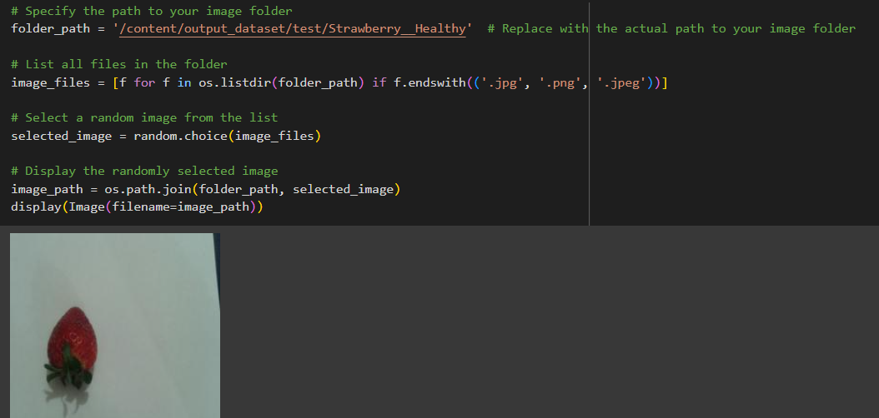
In the above code, I used class strawberry_healthy for prediction, This code randomly selects an image file from a specified folder (folder_path) containing JPEG, PNG, or JPEG files, and then displays the selected image using IPython's display function. It utilizes Python's OS and random modules for file manipulation and random selection, respectively. And It has predicted correctly as strawberry_healthy .

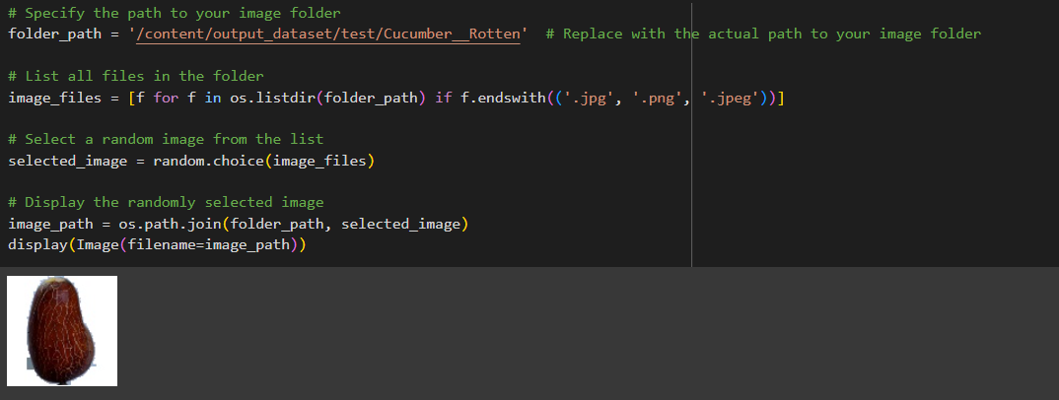
In the above code, I used class cucumber_rotten for prediction, This code randomly selects an image file from a specified folder (folder_path) containing JPEG, PNG, or JPEG files, and then displays the selected image using IPython's display function. It utilizes Python's OS and random modules for file manipulation and random selection, respectively. And It has predicted correctly as cucumber_rotten.
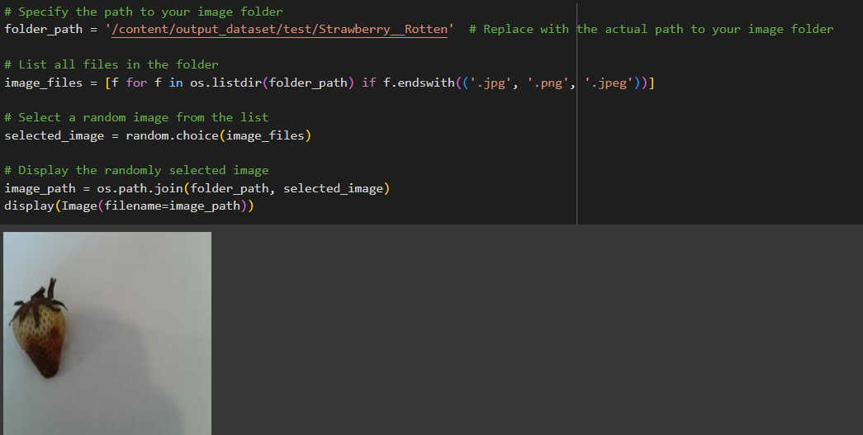
In the above code, I used class strawberry_rotten for prediction, This code randomly selects an image file from a specified folder (folder_path) containing JPEG, PNG, or JPEG files, and then displays the selected image using IPython's display function. It utilizes Python's OS and random modules for file manipulation and random selection, respectively. And It has predicted correctly as strawberry_rotten.

